

IS2102 – Final Assessment
(Due Date: 28 Nov, 2359H)

Name | Student ID
Tan Liang Brighton | A0311651R

Table of Contents
D.1 Wireframes, Activity Diagrams, and Explanations 3
1. The Operating Model 3
2. The Main Business Processes and Business Process Modelling 4
Innovative Features 4
Business Process 1: Register and onboard as a Volunteer 5
Business Process 2: Discover and Join Event as a Volunteer 8
Business Process 3: Create Event and Recruit Volunteers 13
Business Process 4: Generate Impact and Analytic Reports 17
3. Stakeholder Interactions 20
4. Wireframes 21
D.2. Use Case Diagrams 39
D.3. Domain Model Class Diagram 40

D.1 Wireframes, Activity Diagrams, and Explanations

1. The Operating Model
The ImpactHub platform transforms Heartfelt Hands from a reactive, paper-based charity into a data-driven digital organisation. The operating model focuses on three strategic pillars:
Capability Optimisation: Managing Volunteer Resources: Instead of treating volunteers as a labour pool, the system treats them as skilled assets. By capturing Skills and Interests during onboarding as depicted in Business Process 1, the platform enables "Intelligent Recruitment." For Programme Coordinators instead of just listing the event, they can also use the system to send direct invitations to specific volunteers that match the requirements set
Cost Reduction: Streamlining Operations: The platform reduces administrative overhead through features like Pre-emptive Eligibility Validation depicted in Business Process 2 mean that valid actions are processed automatically. Coordinators only intervene when problems arise, allowing a small team to manage a growing volunteer base without increasing headcount.
Evidence-Based Growth: Facilitating Fundraising: The platform directly supports financial sustainability by generating impact reports. The Impact Reporting module (Business Process 4) converts verified volunteer hours into tangible data for grant applications. This allows Administrators to track volunteer impact, offering a holistic view of community.

2. The Main Business Processes and Business Process Modelling
The system integrates the volunteer lifecycle into four interconnected workflows, ensuring data flows seamlessly from recruitment to reporting.

Innovative Features
The ImpactHub platform introduces several key capabilities designed to optimise volunteer engagement and operational efficiency:
Context-Aware Engagement (For User Experience): The platform dynamically adapts the sign-up interface based on the event type. It offers a frictionless "One-Tap Join" for Single-Shift events while providing a robust "Date Selection Interface" for Multi-Shift series, ensuring the user experience is always optimised for the specific commitment level required.
Smart Recommendations (For Volunteers): The system leverages profile data captured during onboarding, specifically Skills and Interests, to curate the "Opportunity Finder." Instead of a static list, the platform proactively prioritises events where the volunteer can make the most impact (e.g., surfacing "Food Delivery" roles for users with a Class 3 Licence), ensuring high relevance and reducing search time.
Intelligent Recruitment (For Programme Coordinators): The platform transforms recruitment from a passive process into an active one. By analysing volunteer Availability Preferences alongside skill sets, the system identifies "High-Confidence Matches" for specific shifts. This allows Coordinators to bypass mass emails and send Direct Invitations to the specific subset of volunteers most likely to accept, optimising fill rates.

Business Process 1: Register and onboard as a Volunteer
Purpose
The primary purpose of the Volunteer Registration process is to convert a website visitor into a verified volunteer with minimal friction. This process is the foundational data-gathering mechanism for ImpactHub. Unlike a standard signup, this workflow captures not just identity, but also skills, interests and availability. This data is the prerequisite for the platform's "Smart Matching" and “Smart Recruiting” innovation, ensuring that the moment a volunteer lands on their dashboard, they see opportunities relevant to them, rather than a generic list.
Scope
• In-Scope:
- Capturing volunteer identity (Name, Email, Mobile Number) and secure credential creation
- Identity Verification via One-Time Password (OTP) to ensure valid contact details
- Skill Profiling: Allowing users to self-select functional skills and personal Interests
- Availability Definition: Capturing general weekly availability preferences
- Data Validation: Checking for already existing accounts
- Review & Edit: Allowing the user to verify all data before final submission
- Account Creation: Generating the database record and logging the user in
- Automated Risk Assessment: Automatically identifies skills that require proof (e.g., Driver's License) and flagging them for future verification
- Sequential Eligibility Validation: The system performs a ordered validation check (Qualification > Schedule > Capacity) to determine the user's eligibility state, ensuring safety requirements are prioritised over logistical checks.
• Out-of-Scope:
- Signing up for specific events or shifts
- Manual background checks
- Document Upload & Processing: The actual uploading and manual review of certificates happens in a separate Manage Skills process to ensure registration remains frictionless
Business Value
For the Volunteer: It provides an effortless onboarding experience. By capturing skills, interests, and availability upfront in a Wizard style flow, the system eliminates the need for repetitive data entry later and delivers immediate personalisation.
For Heartfelt Hands: It replaces disjointed manual intake forms with a structured, automated database. It ensures high data quality through verification and allows the organization to instantly audit their resource pool (e.g., "Do we have enough drivers interested in food distribution?"), directly supporting the operating model of efficient resource management.
Business Rules
These are the specific constraints and policies that govern how the ‘Register and onboard as a Volunteer’ process must operate.
- Unique Identity: A volunteer account must be unique based on Email Address and Mobile Number
- Mandatory Verification: Account creation cannot be finalised until the user has successfully verified their mobile number via OTP
- Risk Flagging: Users can self-select skills, but specific High-Risk skills (e.g., Medical First Aid, Driving,) must trigger a system flag for Pending Verification by a Coordinator
- Privacy Consent: The user must explicitly agree to the PDPA/Privacy Policy regarding the storage of personal data before the "Submit" button becomes active.
- Immediate Access: Upon successful registration, the user is automatically logged in and redirected to the Dashboard
- Deferred Verification: If a user selects a "High-Risk" skill (e.g., Medical, Driving) during registration, the system must grant account access immediately but set the skill status to "Pending Upload of Proof" The user is ineligible to apply for shifts requiring those specific high-risk skills until proof is uploaded and verified by an administrator
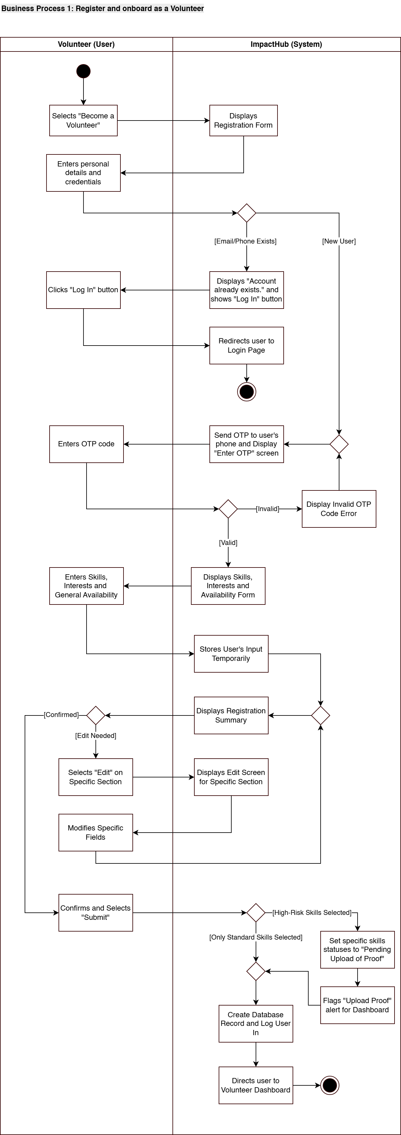

Business Process 2: Discover and Join Event as a Volunteer
Purpose
The purpose of the Discover and Join Event process is to facilitate the efficient matching of volunteer supply with organisational demand. Unlike a passive bulletin board, the "Opportunity Finder" leverages data captured during onboarding to proactively surface events that align with a volunteer's specific Skills and Interests.
Crucially, this process serves as the system's primary enforcement point for operational rules. It automatically performs an ordered validation check, checking for qualifications and time conflicts. This validation logic is context-aware: it enforces verification for high-risk roles (e.g., Driving) while remaining lenient for standard roles (e.g., Serving), allowing volunteers to sign up for general tasks even if they do not have the listed skills in their profile to reduce entry friction.
Simultaneously, the process promotes flexible engagement via a context-aware join flow. For simple Single-Shift events, the system offers a frictionless "One-Tap Join." For complex Multi-Shift events, it presents a dedicated Date Selection Interface, allowing volunteers to build a custom schedule or quickly select multiple shifts (e.g., next 4 shifts, next available shift) via adaptive quick-select options.
Scope
• In-Scope:
- Smart Discovery: Displaying a personalised "Opportunity Finder" sorted by the user's specific skills and interests
- Pre-emptive Qualification Check: Automatically disabling the join button for high-risk roles if the user lacks the required high-risk skills (or proof is pending), accompanied by explanatory text
- Context-Aware UI: Dynamically rendering the primary action button based on the event type: "Join Event/Waitlist" (for Single-Shift Events) or "Select Dates" (for Multi-Shift Events).
- Single-Shift Streamlining: Bypassing the date selection screen for Single-Shift Events to allow immediate roster or waitlist entry provided the user is eligible
- Date & Time Selection Interface: A dedicated screen (for Multi-Shift Events only) presenting specific shift slots with live status indicators for each slot (Available/Full)
- Waitlist Entry: Automatically queuing a user to the waitlist if the specific shift slot (Single-Shift Event) or selected shift slot (Multi-Shift Event) is full
- Valid Date Filtering: Restricting the calendar view so that only dates matching the event's defined schedule are selectable and all other dates are disabled.
- Manual Selection: Allowing users to manually toggle specific valid shift slots on or off
- Standard Skill Leniency: Allowing volunteers to sign up for roles with no high-risk requirements (e.g., Server) even if they do not have the listed skills in their profile
- Confirmation: Displaying a summary screen that explicitly categorises results into "Successfully Joined" and "Added to Waitlist"
- Dashboard update: Updating the user dashboard with the new commitments after successful confirmation.
• Out-of-Scope:
- Cancellations or post-confirmation modifications (Managed in Manage Personal Schedule)
- Uploading of the verification documents for skills (Handled in Manage Profile)
- Waitlist Promotion/Management: The background process of moving a user from the waitlist to the roster when a spot opens
- Waitlist Notification: Notifying of user if they are promoted from the waitlist to the roster
Business Value
For the Volunteer: It respects their time and capabilities. The "Date Selection" interface eliminates the frustration of guessing which dates are open. The "Quick Select" options remove the friction of manual weekly sign-ups, while manual selection offers total control for those with irregular schedules.
For the Programme Coordinator: It significantly reduces administrative overhead. By pre-validating eligibility, the system ensures that the coordinator does not need to manually vet every sign-up. By allowing "Partial Fulfillment", the system ensures that volunteers can waitlist dates that are full and continue to book other days that are still available. The Waitlist feature also provides an automatic safety net for staffing, reducing the stress of finding last-minute replacements.
For Heartfelt Hands: It ensures operational reliability. The system automatically adheres to safety protocols for high-risk roles, mitigating liability risks while maintaining a steady flow of volunteers for general operations.
Business Rules
These are the specific constraints and policies that govern how the ‘Discover and Join Event as a Volunteer’ process must operate.
- Smart Default: The "Opportunity Finder" view must default to showing events that match the user's Interests and Skills first
- High-Risk Enforcement: If a shift requires a High-Risk Skill (e.g., Driving) and the user's skill status is "Pending Upload of Proof" or if skill is not present, the "Join" button must be disabled with clear explanatory text
- Conflict Prevention: A volunteer cannot join an event (or select specific shift slots) if they are already rostered for another event that overlaps with that time slot. These conflict slots will be disabled
- Single-Shift Event Logic - If an event is defined as a Single-Shift Event:
  - Display "Join Event" if open slots are available, clicking it immediately adds the user to the roster
  - Display "Join Waitlist" if event is full, clicking it immediately adds the user to the waitlist queue
- Multi-Shift Event Logic - If an event is defined as a Multi-Shift Event:
  - Display "Select Dates". This opens the Date & Time Selection Interface. Users must manually select the specific shift slots they wish to attend
- Standard Skill Leniency: If the role requires only standard skills and no high-risk skills (e.g., Serving, Cleaning) but the user’s indicated skills do not match, the user will still be eligible to sign-up.
- Partial Fulfillment: If the user selects multiple days, the system processes each date in one transaction. Available dates are booked while full dates are waitlisted.
- Waitlist Protocol: Users added to the waitlist are timestamped to ensure First-In-First-Out (FIFO) priority.
- Double Booking: A user cannot be on the Roster and the Waitlist for the same event simultaneously
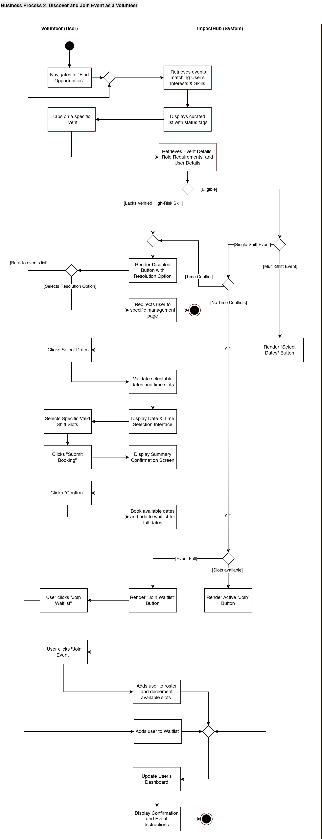

Business Process 3: Create Event and Recruit Volunteers
Purpose
The purpose of the Create Event and Recruit Volunteers process is to enable Programme Coordinators to efficiently create volunteer opportunities and proactively fill shifts with the most suitable candidates. This workflow supplements manual recruitment methods with a centralised Smart Roster system. Its core innovation is Intelligent Recruitment: rather than waiting for volunteers to discover events passively, the system actively scans the database to identify "High-Confidence Matches" (volunteers whose availability, interests, and skills align with the event's specific requirements) and provides Programme Coordinators with the option to send Direct Invitations to those volunteers, with the invitation appearing directly on the volunteer’s dashboard.
Scope
• In-Scope:
- Basic Event Definition: Creating new events with static parameters (Title, Location, Description) that apply to all potential shifts.
- Schedule Branching: Distinct workflows for Single-Shift, Recurring Pattern (e.g., Every Friday), and Custom Multi-Date (Irregular dates) schedules.
- Recurrence Options: Providing standard preset patterns (Daily, Weekly, Bi-weekly, Monthly, Yearly) and a Custom Interval option (e.g., "Every 3 weeks") for rule-based schedules.
- Manual Date Picker: A visual calendar interface allowing coordinators to multi-select specific irregular dates (Manual Selection).
- Schedule Configuration: Selecting the event structure (Single-Shift vs Multi-Shift) before defining specific dates and times.
- Shift Configuration: Defining Roles and Capacity that apply to the selected date(s).
- On-Demand Intelligent Matching: The system scanning the database for "High-Confidence Matches" when selected by the Coordinator
- Direct Invitations: Sending targeted invitation cards directly to the dashboards of identified "High-Confidence Matches".
- Public Listing: Publishing the event to the general "Opportunity Finder" calendar for all volunteers to see
• Out-of-Scope:
- The actual sign-up action by the volunteer (Covered in Discover and Join Event)
- Managing day-of attendance or cancellations
- Hour-Logging Approval Queue
- Editing or cancellation of events
Business Value
For the Programme Coordinator: It significantly improves recruitment efficiency. Instead of relying solely on passive sign-ups or manual email chains, the coordinator can proactively target the specific subset of volunteers who are most likely to accept the role. The Weekly Grid interface streamlines the setup of complex rosters, reducing the time required to manage repeating schedules
For Heartfelt Hands (Organisation): It optimises resource utilisation. By surfacing opportunities to volunteers who have expressed a specific interest in the cause and possess the right skills, the organisation improves volunteer engagement and satisfaction, ensuring that the most capable hands are on deck for complex tasks.
Business Rules
These are the specific constraints and policies that govern how the ‘Create Event and Recruit Volunteers’ process must operate.
- Schedule Hierarchy: The system must enforce a top-level decision between Single-Shift and Multi-Shift.
- Multi-Shift Logic: If Multi-Shift is selected, the Coordinator must choose the generation method:
  - Recurring Pattern: The user selects a rule:
    - Presets: Daily, Weekly, Bi-weekly, Monthly, Yearly
    - Custom Interval: User defines specific numeric intervals (e.g., "Every X Days") and specific days of the week
  - Method B: Manual Selection: The user manually selects non-sequential/irregular dates from a calendar view
- Uniform Shift Application: The Shift Roles and Times defined in the wizard are applied to all generated dates in the series by default
- Recruitment Optionality: The "Smart Recruitment" workflow is optional. Coordinators must be able to bypass the matching process and immediately publish the event to the public calendar if targeted invitations are not required
- High-Confidence Threshold: A volunteer is only flagged as a "High-Confidence Match" if they meet all three criteria: (1) Possess the required Skill (if applicable), (2) Have a matching Interest tag, and (3) Have indicated an Availability preference for that specific time slot
- Role Integrity: Every event must have at least one defined Shift Role with a capacity greater than zero.
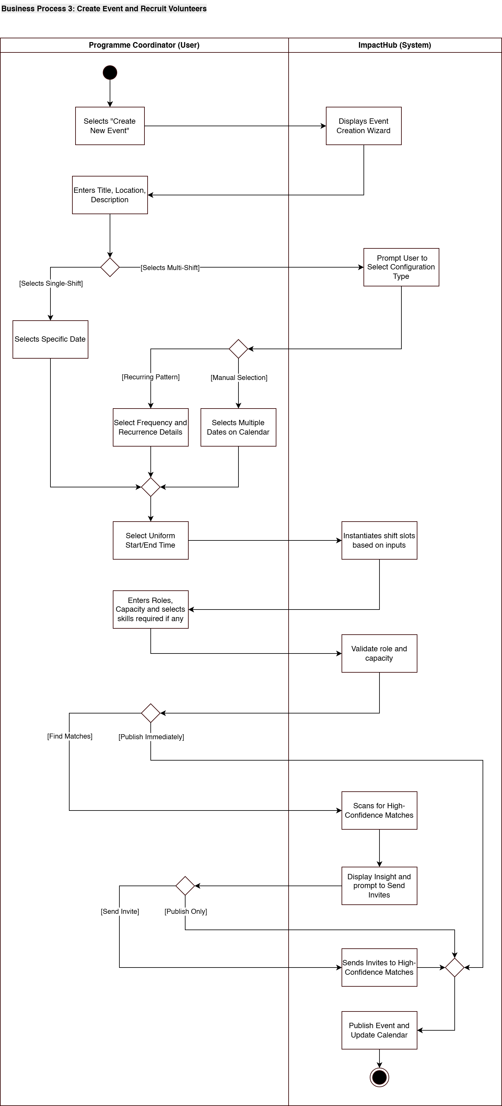

Business Process 4: Generate Impact and Analytic Reports
Purpose
The purpose of the Generate Impact and Analytic Reports process is to transform raw operational data into strategic insights. While volunteers and coordinators focus on day-to-day execution, this process empowers Organisation Administrators to visualise the cumulative effect of those efforts. It replaces static, manual spreadsheet calculations with a dynamic Analytics Engine, enabling the organisation to demonstrate accountability to the board of directors, secure funding through evidence-based grant applications, and optimise future resource allocation based on historical trends.
Scope
• In-Scope:
- Dashboard Visualisation: Providing a real-time "Global Impact Dashboard" for an at-a-glance view of key metrics (Total Hours, Active Volunteers, Retention Rate)
- Report Configuration: Allowing Administrators to define specific parameters for reports (e.g., Timeframe: "Year-End", Category: "Food Bank", Metric: "Total Hours")
- Trend Analysis: Visualising data over time to identify seasonality or engagement drops
- Report Generation: Aggregating verified data into downloadable formats (PDF/CSV)
- Privacy Processing: Automatically applies privacy filters based selection by administrator, anonymising data for public consumption while retaining granular detail for internal board review
• Out-of-Scope:
- The actual logging and verification of hours (performed by Volunteers and Coordinators)
- Converting abstract metrics into tangible impact statements (e.g., dollar value conversions
- Automated distribution of reports to stakeholders
Business Value
For the Administrator: It reduces the time required for reporting. Instead of spending days collating data from spreadsheets, the admin can generate a comprehensive Board Report in minutes
For Heartfelt Hands (Organisation): It ensures financial sustainability. Grant providers require rigorous, data-backed proof of impact. This process provides accurate, granular data that strengthens funding applications and fosters trust with donors
Business Rules
These are the specific constraints and policies that govern how the ‘Create Event and Recruit Volunteers’ process must operate.
- Schedule Hierarchy: Data Integrity: Reports can only include "Verified" data (hours approved by Coordinators). Pending or Rejected logs must be excluded from official impact totals to ensure accuracy
- Access Control: Only users with the "Organisation Administrator" role can access sensitive organisational data or generate full organisational reports
- Privacy Processing: The system automatically determines data visibility based on the selection from the administrator. External-facing formats must strip individual volunteer names (Aggregation), while internal Board formats retain operational detail
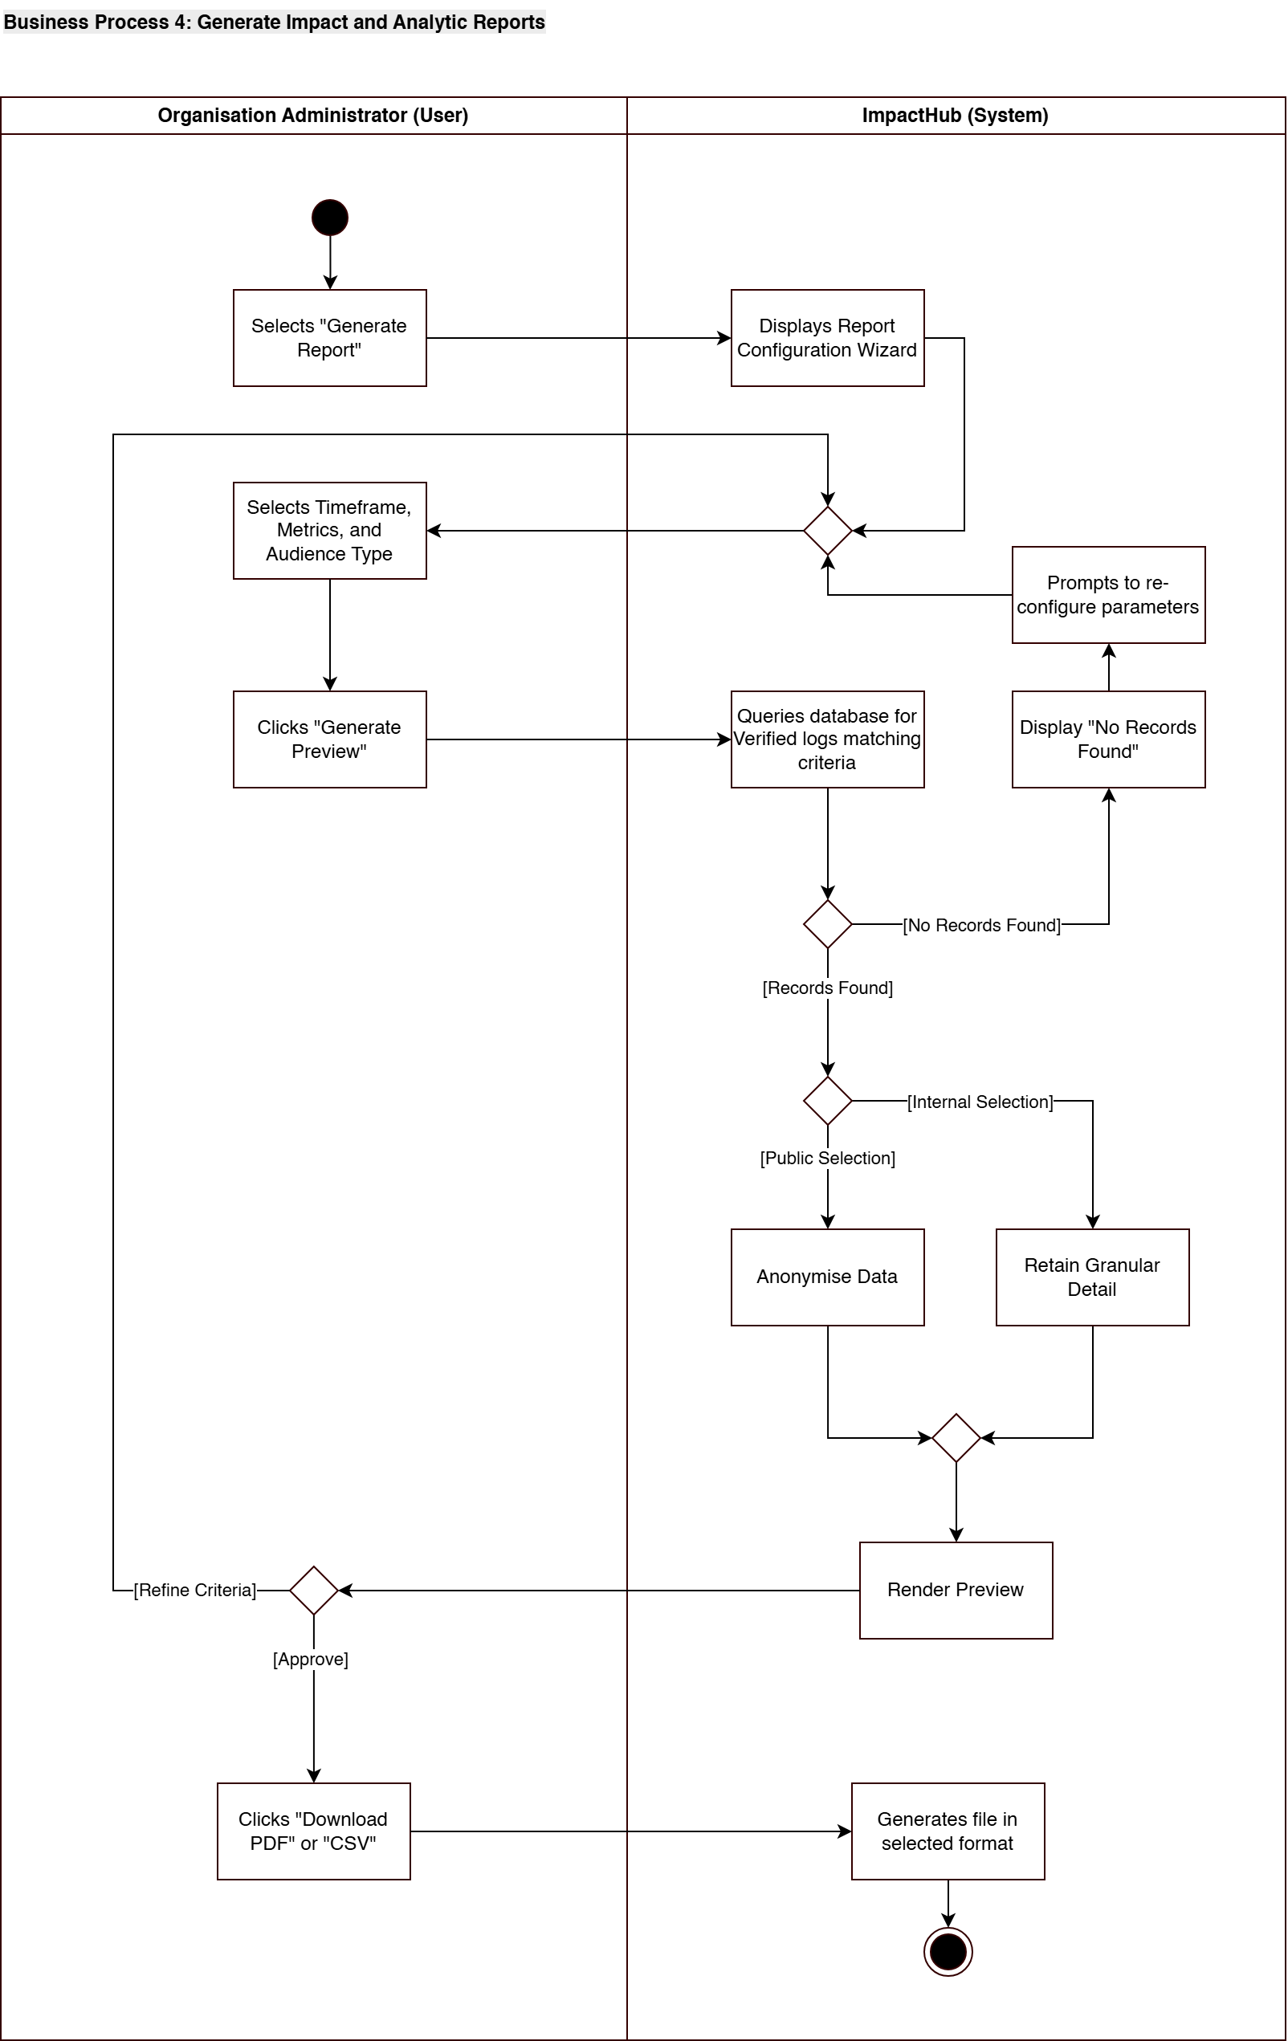

3. Stakeholder Interactions
This section details how the three core user groups interact with the ImpactHub platform to achieve their specific goals. The system is designed to shift user interactions from "reactive data entry" to "proactive decision making."

Volunteers
Volunteers interact with ImpactHub primarily as a personalised concierge rather than a static bulletin board
Discovery: Instead of manually filtering through irrelevant listings, the volunteer is presented with a curated "Smart Recommendations" feed immediately upon login. This feed leverages the Skills and Interests data captured during the onboarding process (Business Process 1) to surface opportunities where they can be most effective.
Commitment: The interaction creates a "path of least resistance." For simple tasks, volunteers utilise the One-Tap Join feature (Business Process 2), removing the barrier of complex forms. For complex schedules, the Date Selection Interface allows them to fit volunteering around their lives, not the other way around
Retention: Post-event, the volunteer interacts with their personal Impact Dashboard, which provides immediate positive reinforcement by visualising their accumulated hours and specific contributions, fostering a sense of belonging and encouraging repeat engagement.

Programme Coordinators
Coordinators interact with the platform to optimise "Fill Rates" and ensure operational coverage without administrative burnout
Recruitment: The primary shift in interaction is moving from "Broadcast" to "Target." Instead of sending mass emails and hoping for replies, Coordinators can use the smart matching feature (Business Process 3). They interact with the system to identify "High-Confidence Matches" who are volunteers who are qualified, interested, and available, and send Direct Invitations. This transforms recruitment from a passive waiting game into an active, targeted selection process.
Operational Control: The Roster Dashboard provides a real-time "Red/Green" status view of upcoming shifts. Coordinators interact with this view to identify gaps instantly. The system creates an exception-based interaction model: Coordinators are only notified when a shift is under-capacity or requires high-risk skill verification, allowing them to focus on resolving issues rather than monitoring routine sign-ups.

Organisation Administrators
Administrators interact with ImpactHub to convert operational data into organisational sustainability and governance.
Strategic Oversight & Trend Analysis: The Administrator will be able to see an overview of the organisation via the Global Impact Dashboard. Their interaction focuses on identifying macro-trends such as analysing the "Retention Rate" of volunteers recruited or spotting "Participation Drops" in specific events. This allows them to make data-driven decisions on where to allocate budget or which programs require intervention
Evidence Gathering: The Administrator interacts with the Report Generator (Business Process 4) to clearly demonstrate the organisation's impact to stakeholders and grant providers. By filtering verified log data, they generate the necessary evidence for grant applications. When required, admins can also ensure that data presented to external stakeholders (Board Members, Donors) is automatically anonymised for privacy while remaining aggregated accurately for impact proof.
Database Governance: While Volunteers onboard themselves , the Administrator interacts with the Volunteer Database to ensure the integrity of the "Smart Matching" ecosystem. They manage the high-level configuration of Skills and Interests tags, ensuring that the categorisation used in the "Opportunity Finder" remains relevant. This interaction ensures that the data feeding into the operational processes remains clean and standardised.

4. Wireframes

D.2. Use Case Diagrams

D.3. Domain Model Class Diagram

